**AWS Task-3**

**Task Description:**

1. Create a S3 bucket, with no public access and upload files to the bucket & view the logs using cloudwatch for the uploaded files.
2. Launch two ec2-instances and connect it to a application load balancer, where the output traffic from the server must be an load balancer IP address

Explanation:

1. Login to Aws console and navigate to S3.

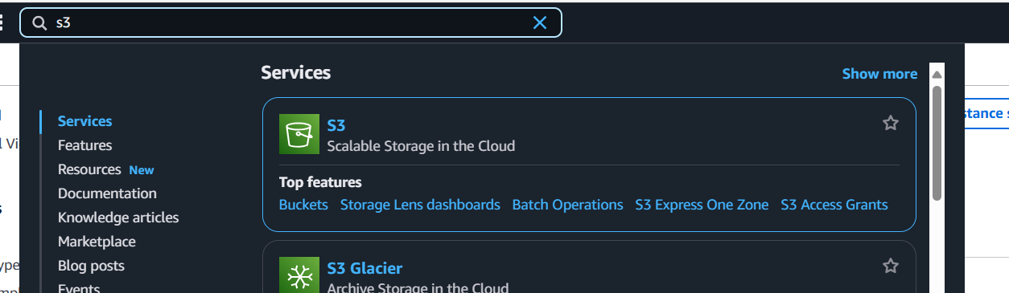

Click create bucket.

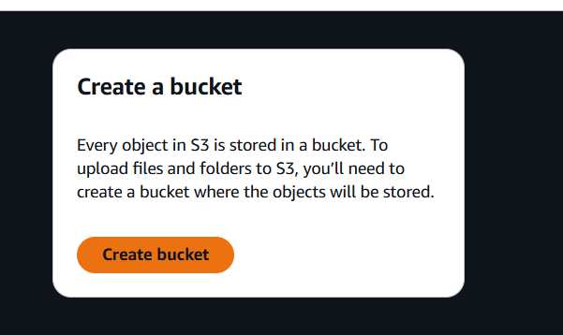

Give the bucket name – mytaskbuckett and ensure block all public access is checked. Then click create bucket.

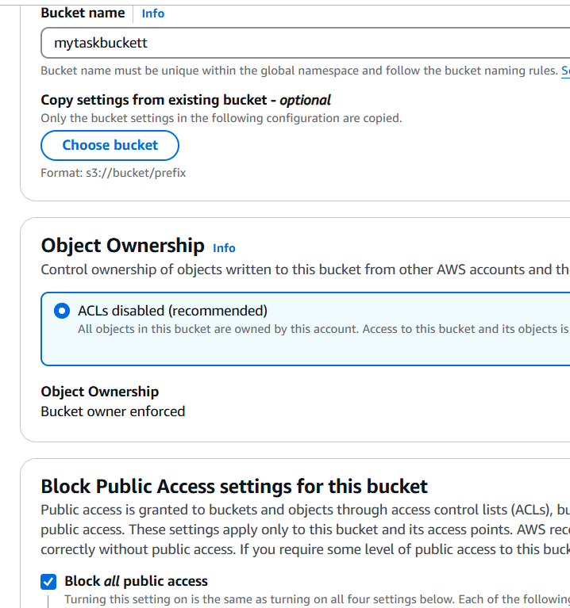

1. Navigate to the created bucket and click upload. Upload the file from your system.

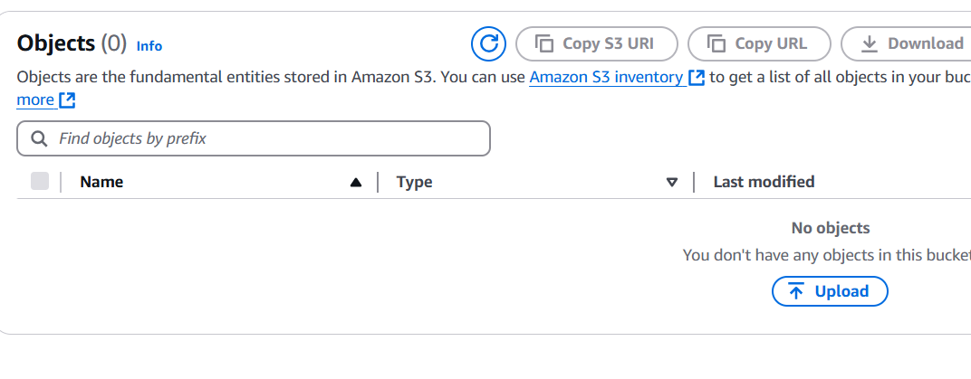

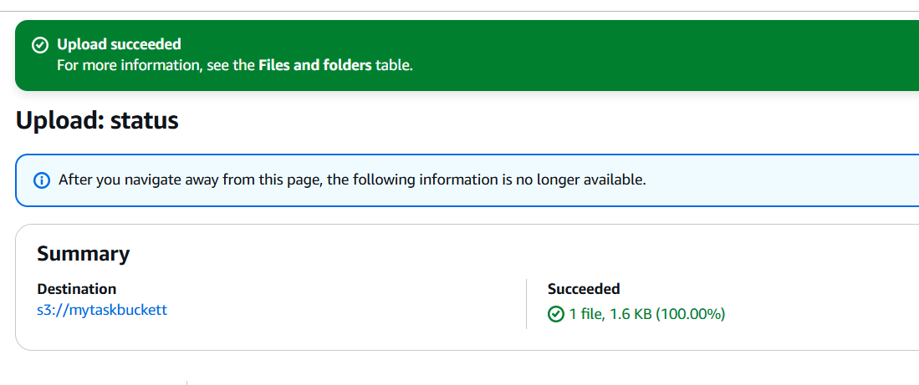

Navigate to the created bucket and go to properties

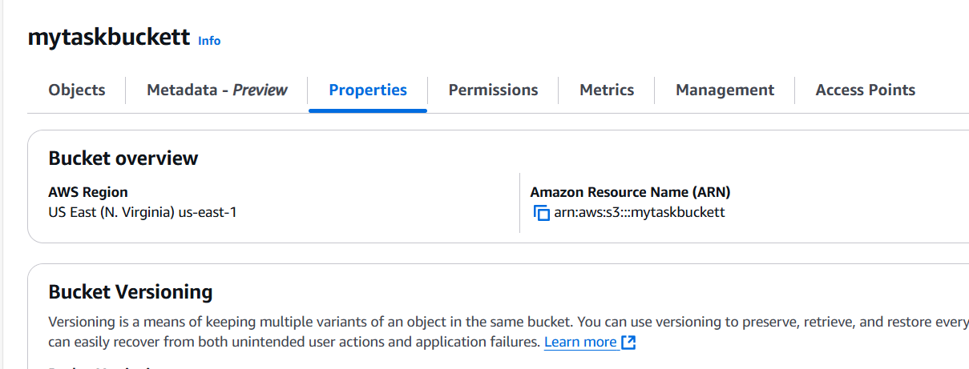

Go to server access logging , edit and enable the server access logging.

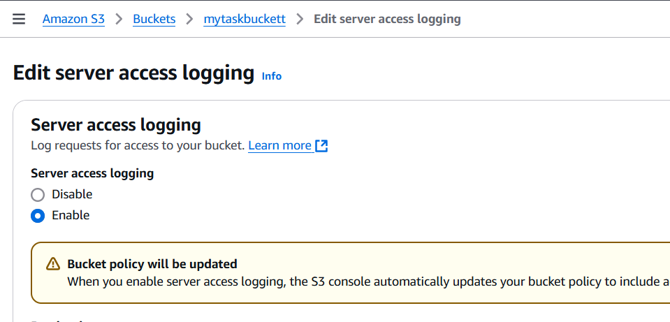

Choose the target bucket to save logs.

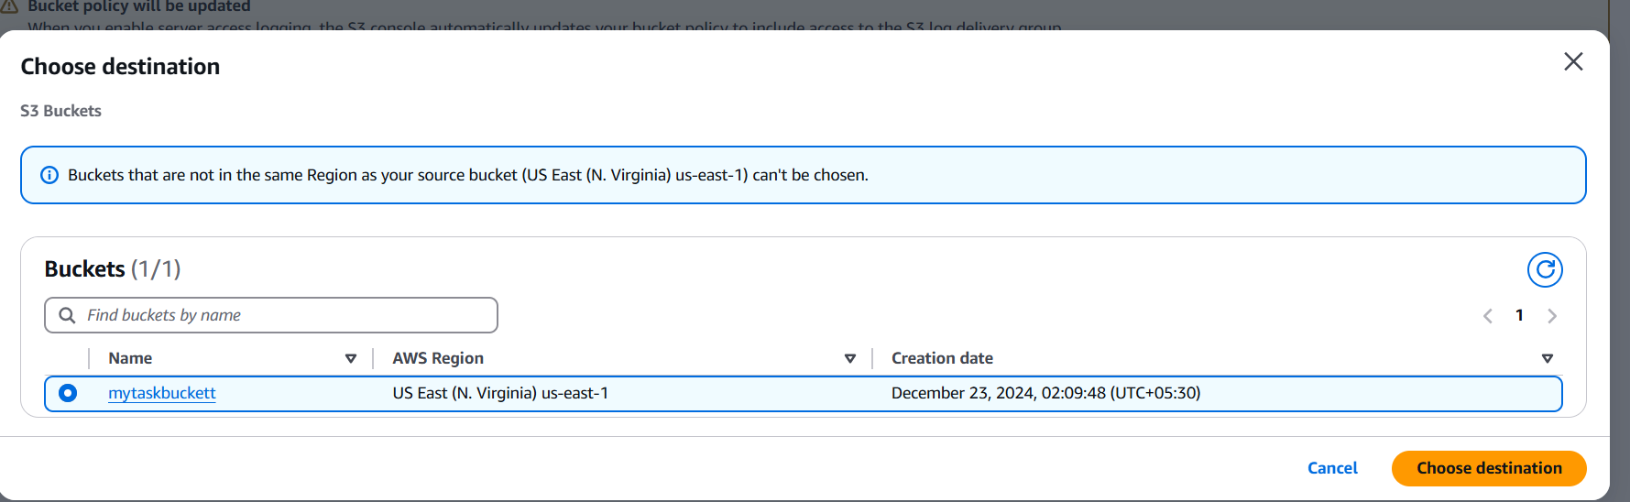

1. Navigate to cloud trail

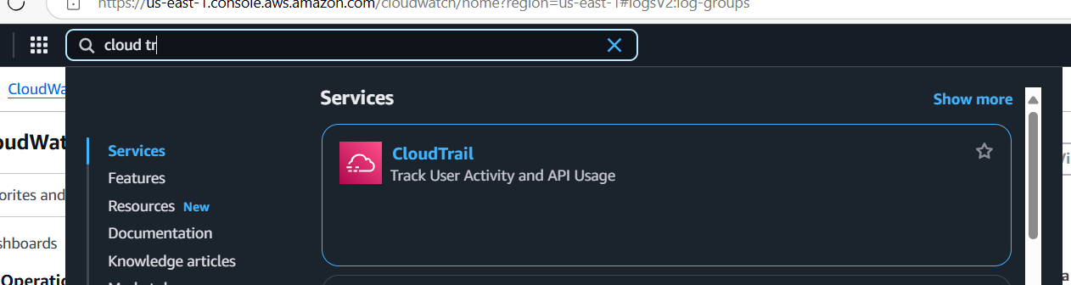

Create trail > trail name – s3-trail > create the trail

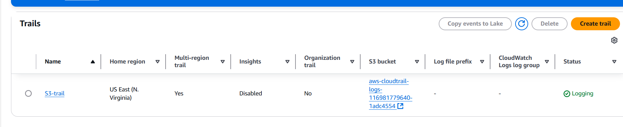

Navigate to cloud watch in aws console

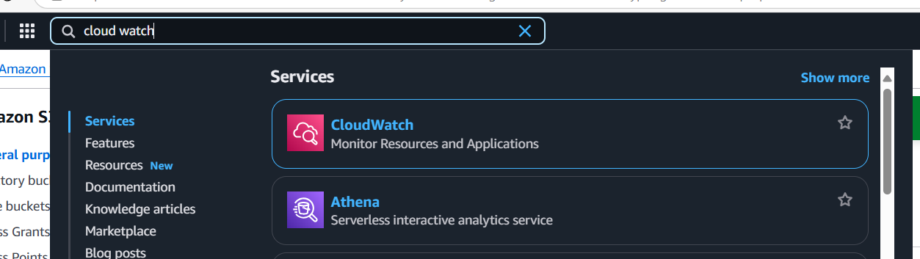

Navigate to logs and click log groups, the logs can be found which is generated by the cloud trail and upload activity can be found.

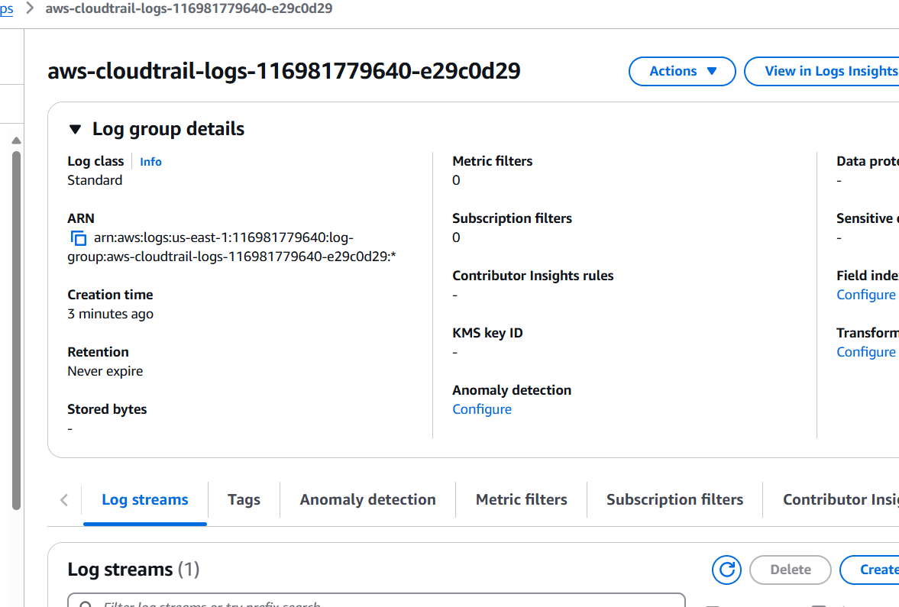

Task 2:

1. Launch 2 EC2 instance

AMI: Select Amazon Linux 2 AMI

Instance Type: Choose t2.micro

Network settings and security group as below:

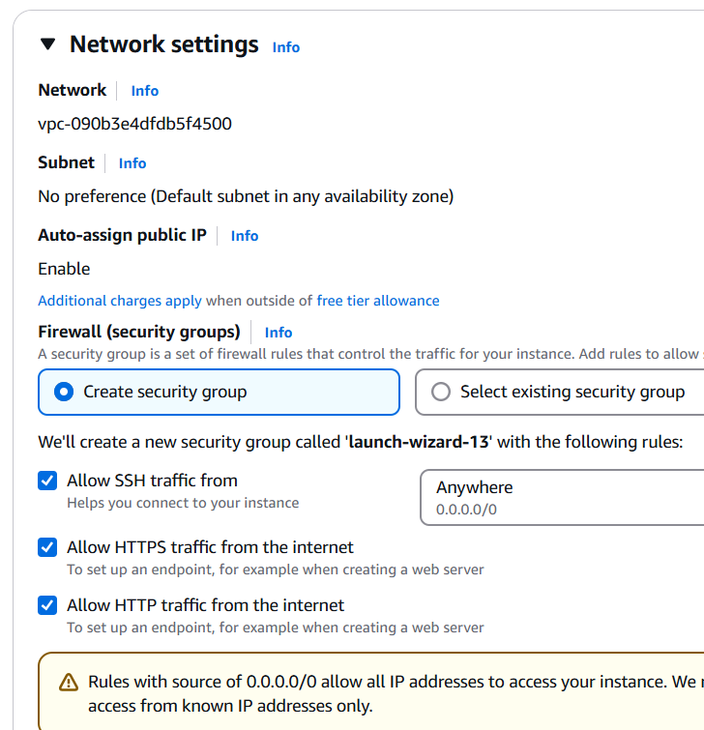

Launch the instance and name as instance1 and instance2.

1. Connect via ec2 connect and install webserver on each instance by

sudo yum update -y

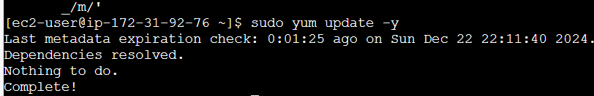

sudo yum install -y httpd

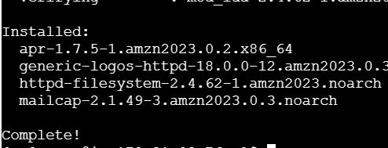

echo "Server 1" | sudo tee /var/www/html/index.html for 1st instance



echo "Server 2" | sudo tee /var/www/html/index.html



sudo systemctl start httpd



1. Navigate to EC2>Load balancer>create new load balancer

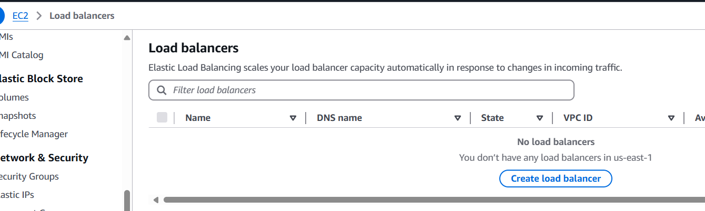

Choose Application load balancer and create. Give the load balancer name as below and choose internet facing.

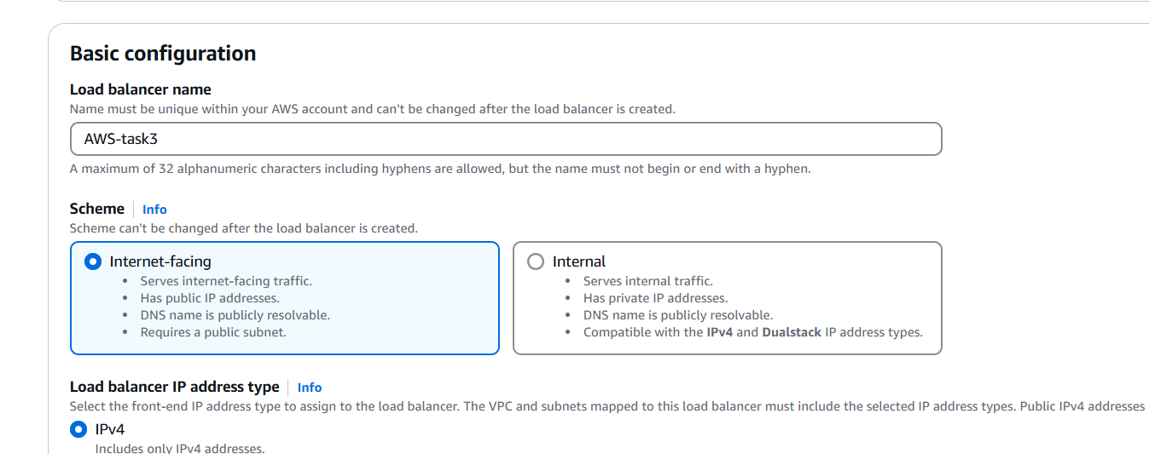

Select availability zones

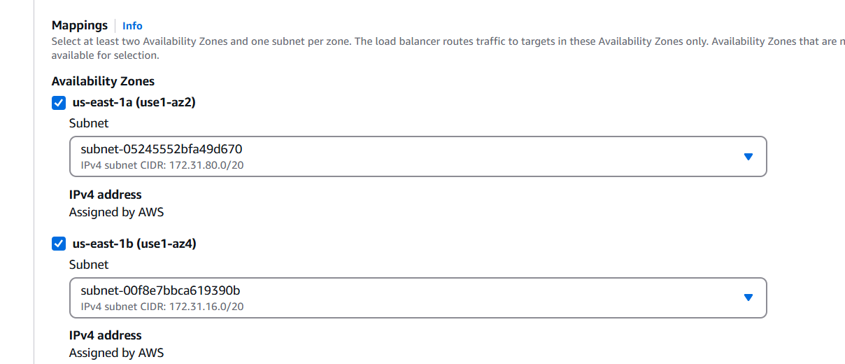

Add http port 80 under listeners.

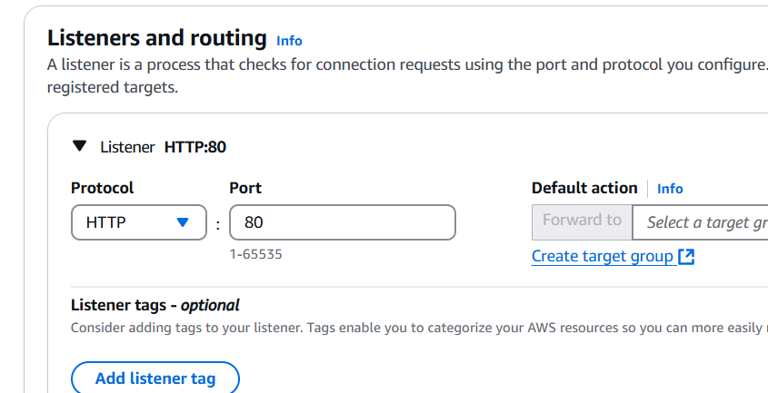

Create target group

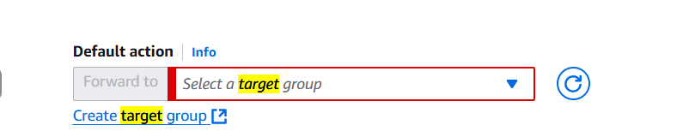

Target Type: Instances.

Protocol: HTTP (port 80).

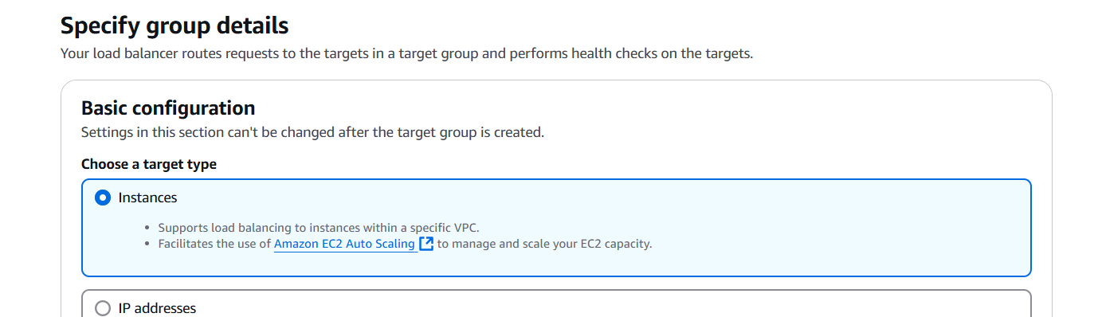

Add 2 instances to the target group.

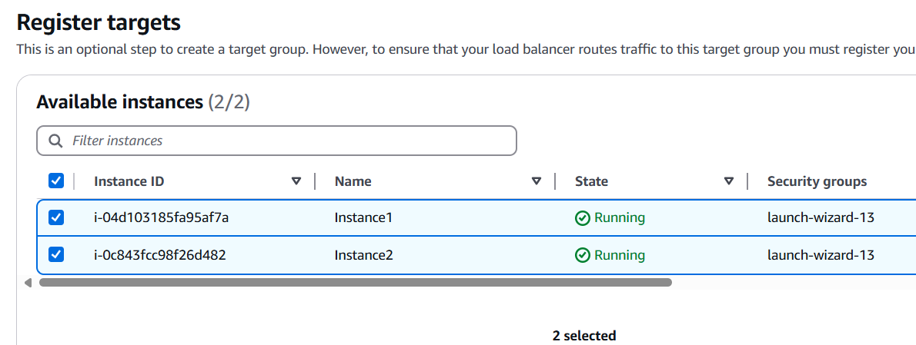

Choose the created target group in create load balancer section

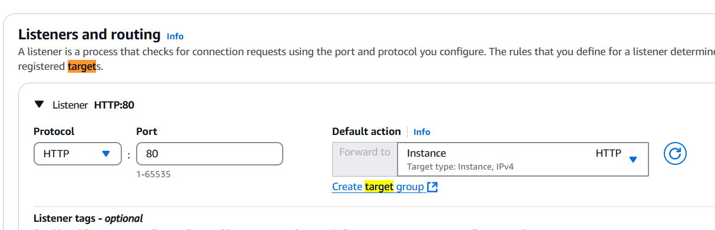

Then click create.

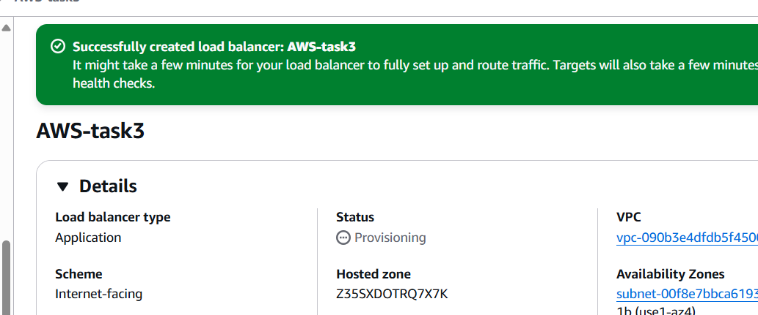

1. Copy the DNS name of the created load balancer,

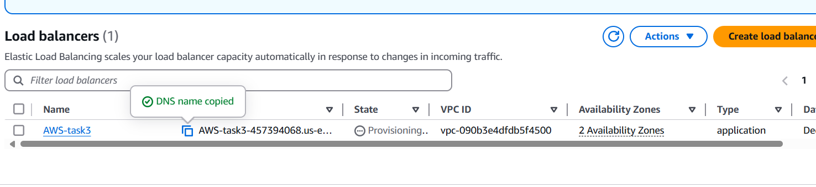

1. Verify it in the browser

http:// AWS-task3-457394068.us-east-1.elb.amazonaws.com

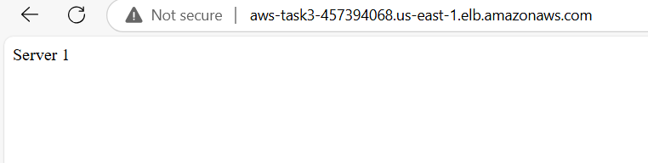

Post refreshing, it will be server2

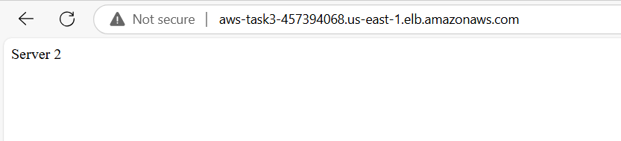

ALB is routing traffic correctly.